## Software Installation Requirements Windows

Depending on your windows setup, try the following steps.

1. Install the [Windows SDK for Windows](https://developer.microsoft.com/en-us/windows/downloads/windows-8-1-sdk)
2. Install [Python 2.7](https://www.python.org/download/releases/2.7/) if not already installed, and make sure to [add its install location to your PATH](http://www.anthonydebarros.com/2014/02/16/setting-up-python-in-windows-8-1/)
3. Install [git](https://git-scm.com/download/win) if you don't have it and add it to your PATH
4. Install OpenSSL from [here](http://slproweb.com/products/Win32OpenSSL.html). Make sure to choose the right package for your architecture, and only install the full package (not the light version). You must install OpenSSL at its recommended location — do not change the install path
5. Download and install node v12.15 (install the 12+ version)
6. At windows start, run PowerShell administrator mode
7. Create a directory where you can easily your work and modules

mkdir mywork

1. Then “cd mywork” to go into that directory
2. npm install windows-build-tools
3. npm install ganache-cli web3 solc
4. And the prompt->
   1. node_modules/.bin/ganache-cli.cmd

If this does not work for you. Try to follow the following steps.

1. Install [Visual Studio Community Edition](https://beta.visualstudio.com/downloads/). If you choose a custom installation, the bare minimum items that need to be checked are all pertaining to Visual C++ (Current version is VS 2019)
2. Install the [Windows SDK for Windows](https://developer.microsoft.com/en-us/windows/downloads/windows-8-1-sdk)
3. Install [Python 2.7](https://www.python.org/download/releases/2.7/) if not already installed, and make sure to [add its install location to your PATH](http://www.anthonydebarros.com/2014/02/16/setting-up-python-in-windows-8-1/)
4. Install [git](https://git-scm.com/download/win) if you don't have it and add it to your PATH
5. Install OpenSSL from [here](http://slproweb.com/products/Win32OpenSSL.html). Make sure to choose the right package for your architecture, and only install the full package (not the light version). You must install OpenSSL at its recommended location — do not change the install path
6. Download and install node v12.15
7. At windows start, run PowerShell administrator mode
8. npm install windows-build-tools
9. npm install ganache-cli web3 solc
10. And the prompt->
    1. node_modules/.bin/ganache-cli.cmd
11. [Environment]::GetEnvironmentVariable("Path")
    1. If it doesn’t work, find the path of npm, and run it from there

## MacOS

If you do not have homebrew installed, please install homebrew by following the instructions at <https://brew.sh/>. Homebrew is the package manager which will help us install all other software required for our development. Install, all using homebrew.

Ganache, use, gui version <http://truffleframework.com/ganache/>

Linux

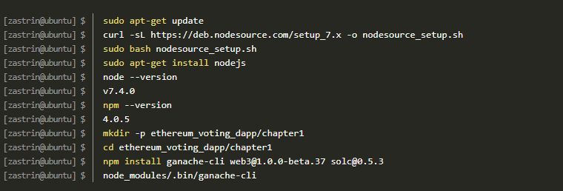

If you are successful, you will see the following output:

